

Mini project Report Social progress Index Analysis using Python

**SUBMITTED BY:**

M.Praveen kumar -(22102A030215)

M.Shiva -(22102A030216)

M.Suchitra -(22102A030217)

M.Jayanth Reddy -(22102A030218)

M.Rushmitha Gowd -(22102A030219)

M.Chandana Reddy -(22102A030220)

M.Arshiya -(22102A030221)

**SUBMITTED TO:**

**DR. RAMANI MADAM**

|  |  |
| --- | --- |
| **Table of contents** | **Page No** |
| Introduction | 3 |
| Problem Definition, Data set | 4-6 |
| Modules,  Source code | 7-9 |
| Result | 10-15 |
| Conclusion | 16 |

**Table of Contents:**

**INTRODUCTION :-**

An indicator of social advancement around the world is the Social Progress Index (SPI). It aids in comprehending how much concern other nations have for the general welfare of their population. This project will walk through a Python-based Social Progress Index. When creating the Social Progress Index, Social Progress Imperative considered hundreds of potential indicators, consulting with MIT experts to identify the metrics that best distinguished between countries' performances. The index employs outcome measures when there are enough data or the most accurate proxies.we used economic category in social progress index

**The following are all the variables taken into account while determining the Social Progress Score:**

1.Property Rights

2.Judical Effectiveness

3.Govt’s Spending

4.Fiscal Spending

5.Business Freedom

6.Labor Freedom

7.Monetary Freedom

8.Trade Freedom

9.Investment Freedom

10.Financial Freedom

Thus, these are the main variables when determining a country's SPI score. On Kaggle, I discovered a dataset with all these elements. Analyzing the Social Progress Index will be useful. The Social Progress Index (SPI) is a measure that gives an understanding of social progress globally. It helps in understanding how much countries care about the overall development of the citizens.

**PROBLEM DEFINITION :-**

The Social Progress Index (SPI) is a valuable tool for assessing the well-being and quality of life of a society. It provides a holistic measurement of social and environmental factors, going beyond traditional economic metrics like GDP. The objective of this project is to perform an in-depth analysis of the Social Progress Index data using Python to gain insights, identify trends, and support evidence-based decision-making,which includes Data Collection,

Data Preprocessing, Exploratory Data Analysis (EDA), Descriptive Statistics, Spatial Analysis,Histogram,Data Visualisation.

**DATA SET:**

Report on World Economy Freedom Analysis

In this report, we will analyze and visualize data related to the economic freedom of various countries. The dataset used for this analysis contains information on 184 countries, including their world rank, region, property rights, judicial effectiveness, government spending, and more. The primary goal of this analysis is to gain insights into the economic freedom of different countries and understand how various factors contribute to their rankings.

Data Overview

The dataset consists of 184 rows and 22 columns, with each row representing a different country. Here are some key points regarding the dataset:

The columns include information on country ID, name, region, world rank, region rank, 2023 score, score range, and various economic indicators.

The dataset has been preprocessed by handling missing values and removing duplicate rows.

The columns contain data types such as integers, floats, and objects (strings).

Key Findings

Top 10 Economically Free Countries

We started by identifying the top 10 economically free countries based on their world rank. Afghanistan, Iraq, and Yemen share the first position, having the lowest world rank, although they have very low 2023 scores.

Top 10 Economically Free Countries

Bar Chart: Country vs. World Rank

We created a bar chart to visualize the relationship between the country and its world rank. The chart provides a quick overview of each country's rank.

Bar Chart: Country vs. World Rank

Bottom 6 Economically Free Countries

We also identified the bottom 6 countries in terms of economic freedom. Eritrea, Zimbabwe, Sudan, Venezuela, Cuba, and North Korea are among the countries with the lowest world ranks, indicating limited economic freedom.

Bottom 6 Economically Free Countries

Stacked Bar Chart: 2023 Score vs. Government Spending

To understand how government spending affects the 2023 score, we created a stacked bar chart. The chart shows how government spending impacts the economic freedom score for each country.

Stacked Bar Chart: 2023 Score vs. Government Spending

Histogram: Distribution of 2023 Score

We generated a histogram to visualize the distribution of 2023 scores among the countries. It helps us understand the spread of scores and their frequency.

Histogram: Distribution of 2023 Score

Pair Plot: 2023 Score vs. Government Spending

The pair plot allows us to explore the relationship between 2023 scores and government spending. It shows how these two variables are related to each other.

Pair Plot: 2023 Score vs. Government Spending

Box Plot: Trade Freedom and Business Freedom

A box plot was used to visualize the distribution of trade freedom and business freedom. It helps in understanding the spread and presence of outliers.

Box Plot: Trade Freedom and Business Freedom

Comparative Analysis: Tax Burden vs. Government Spending

We compared tax burden and government spending using a bar chart to identify trends and relationships between these two indicators.

Comparative Analysis: Tax Burden vs. Government Spending

Line Plot: Tax Burden vs. 2023 Score

A line plot was created to analyze the relationship between tax burden and 2023 scores. It shows how tax burden impacts economic freedom scores.

Line Plot: Tax Burden vs. 2023 Score

**Modules:-**

**Data Manipulation and Analysis:**

Pandas: For data manipulation, cleaning, and analysis.

NumPy: For numerical computations and array operations.

**Data Visualization:**

Matplotlib: For basic data visualization and creating static plots.

Seaborn: Built on Matplotlib, it provides high-level interface for informative and attractive statistical graphics.

Plotly: For interactive and web-based visualizations.

**Statistiscal Analysis:.**

Statsmodels: For statistical modeling and hypothesis testing.

**Time Series Analysis:**

**Datetime:** datetime module can help you convert date and time strings into Python datetime objects for further analysis.

**Source code:**

**import** pandas **as** pd

**import** numpy **as** np

**import** datetime **as** date

**import** seaborn **as** sns

**import** matplotlib.pyplot **as** plt

**%matplotlib** inline

sns**.**set(color_codes**=True**)

In [12]:

file_path**=**"C:/Users/jayan/OneDrive/Documents/World Economy Freedom.xlsx"

df**=**pd**.**read_excel(file_path)

df

df1**=**df**.**dropna() *# Remove rows with missing values*

df1**=**df**.**fillna(20) *# Fill missing values with a specified value*

economy**.**drop_duplicates()

df**.**info()

df**.**index**.**values

df**.**size

df**.**dtypes

df**.**columns**.**values

df**.**head(5)

df.tail(5)

df**.**describe(include**=**"all")

economy_max**=**economy**.**sort_values('World Rank')**.**head(10)

economy_max

df[['World Rank','Country Name']]**.**plot(kind**=**'bar',stacked**=True**)

plt**.**xlabel('country name',fontsize**=**18)

plt**.**title("country vs world rank:Data analysis using Bar Graph")

plt**.**ylabel('world rank',fontsize**=**16)

plt**.**show()

df[['2023 Score',"Gov't Spending"]]**.**plot(kind**=**'bar',stacked**=True**)

plt**.**xlabel('2023 Score',fontsize**=**18)

plt**.**ylabel("Gov't Spending",fontsize**=**16)

plt**.**title("2023 Score vs. Government Spending: Stacked Bar Chart")

plt**.**show()

plt**.**figure(figsize**=**(10, 4))

plt**.**subplot(1, 2, 1)

sns**.**histplot(df['2023 Score'], bins**=**10, kde**=True**)

plt**.**xlabel('2023 Score')

plt**.**ylabel('Frequency')

plt**.**title('Histogram of 2023 Score')

plt**.**show()

plt**.**subplot(1, 2, 2)

plt**.**title("Pair Plot: 2023 Score vs. Government Spending")

sns**.**pairplot(economy[['2023 Score', 'Gov\'t Spending']])

plt**.**show()

sns**.**set(style**=**"whitegrid")

sns**.**boxplot(data**=**df[['Trade Freedom', 'Business Freedom']])

plt**.**title('Box Plot: Trade Freedom and Business Freedom')

plt**.**show()

df**.**groupby(['Tax Burden'])['2023 Score']**.**plot(kind**=**'line',figsize**=**(10,5))

plt**.**xlabel('2023 Score',fontsize**=**18)

plt**.**ylabel('Tax Burden',fontsize**=**16)

plt**.**title("Tax Burden vs. 2023 Score: Trend Analysis")

plt**.**show()

data **=** {

'Country Name': ['Eritrea', 'Zimbabwe', 'Sudan', 'Venezuela', 'Cuba', 'North Korea'],

'World Rank': [171, 172, 173, 174, 175, 176]

}

df **=** pd**.**DataFrame(data)

df **=** df**.**sort_values(by**=**'World Rank')

heatmap_data **=** df[['Country Name', 'World Rank']]

heatmap_data **=** heatmap_data**.**pivot(index**=**'Country Name', columns**=**'World Rank', values**=**'World Rank')

plt**.**figure(figsize**=**(10, 6))

sns**.**heatmap(heatmap_data, cmap**=**'YlGnBu', annot**=True**)

plt**.**title('World Rank Heatmap')

plt**.**show()

x**=**df['2022 Score']

y**=**df['2023 Score']

plt**.**scatter(x,y,color**=**"blue")

plt**.**xlabel('2022 Score',fontsize**=**18)

plt**.**ylabel('2023 Score',fontsize**=**16)

plt**.**title("2023 Score vs. 2022 Score: Scatter Plot Comparison")

plt**.**show()

labels**=**['Eritrea', 'Zimbabwe', 'Sudan', 'Venezuela', 'Cuba', 'North Korea']

sizes **=**[171, 172, 173, 174, 175, 176]

plt**.**pie(sizes, labels**=**labels, autopct**=**'%1.1f%%', startangle**=**140)

**RESULTS:-**

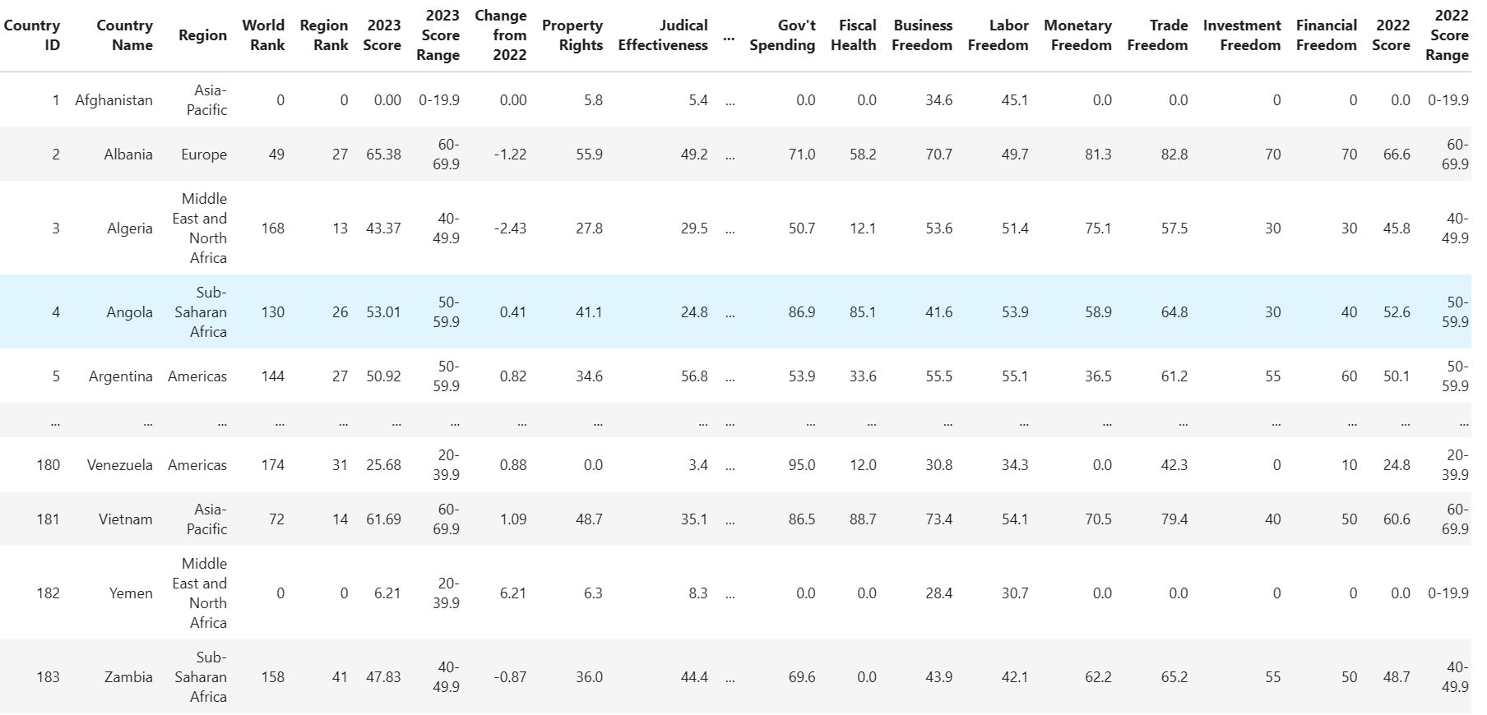

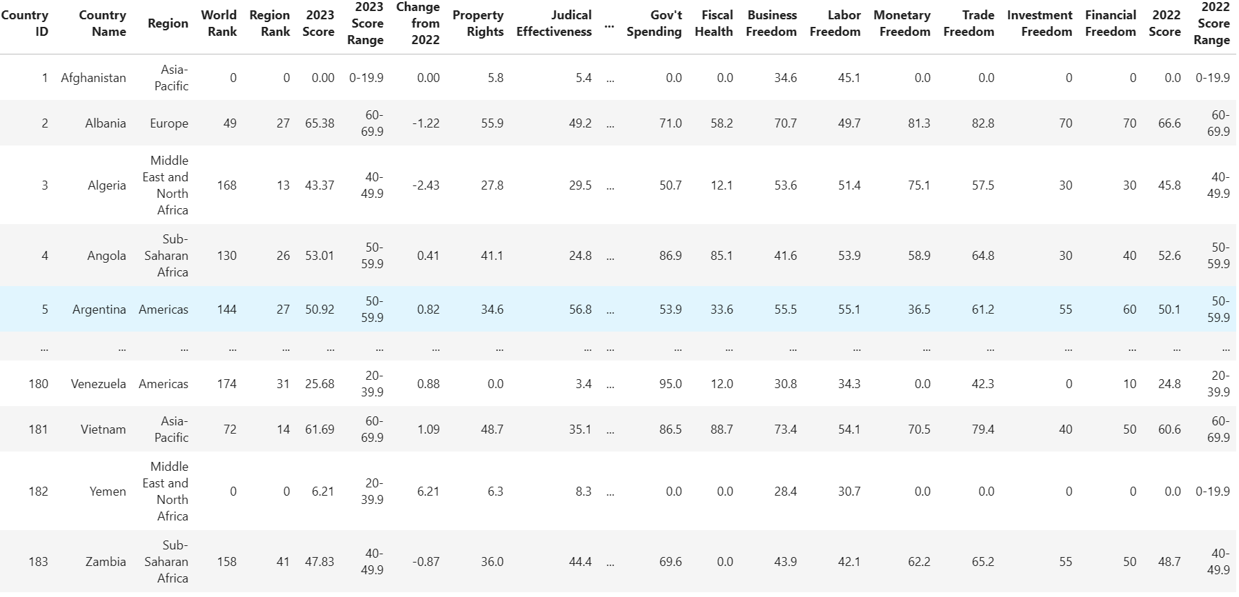

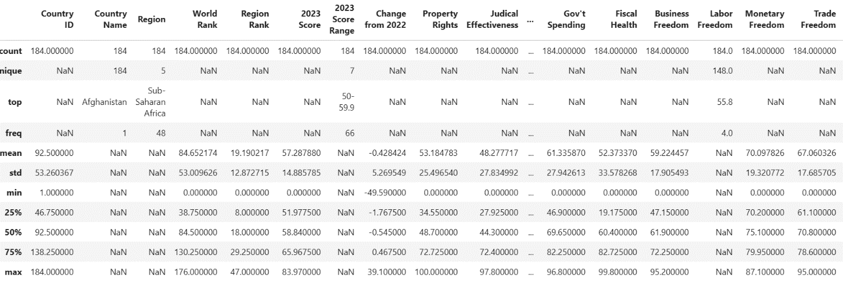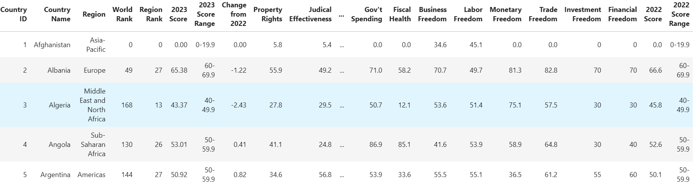

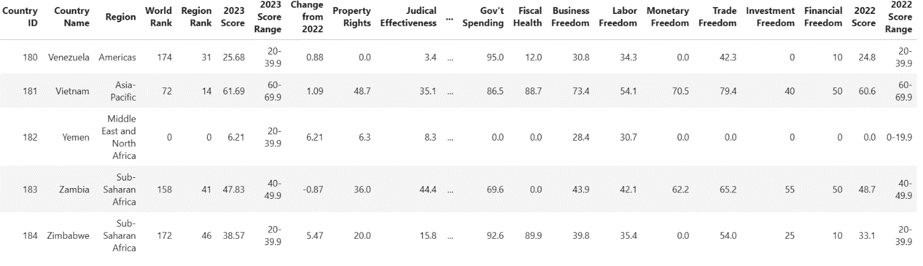

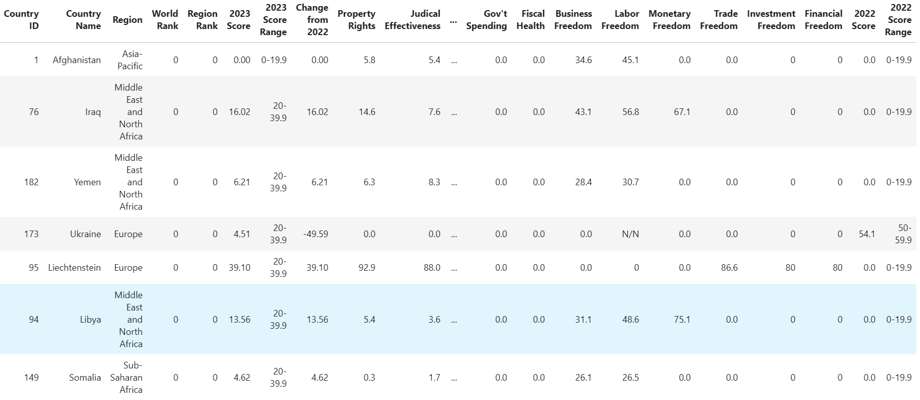

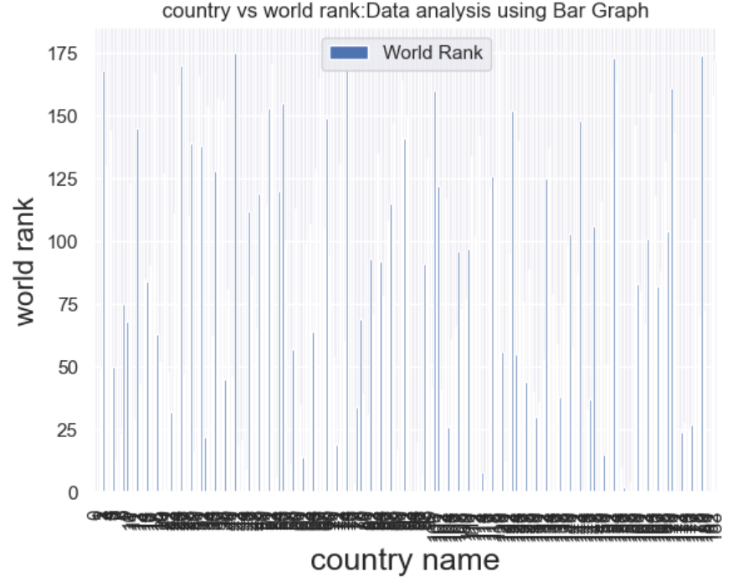

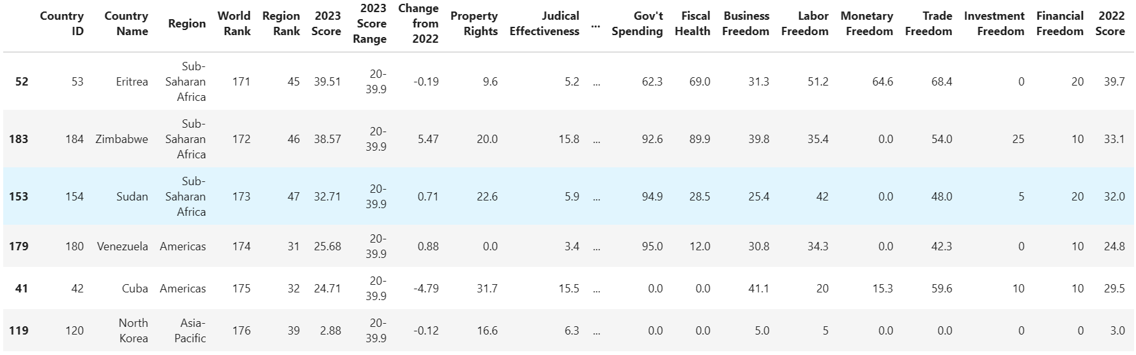

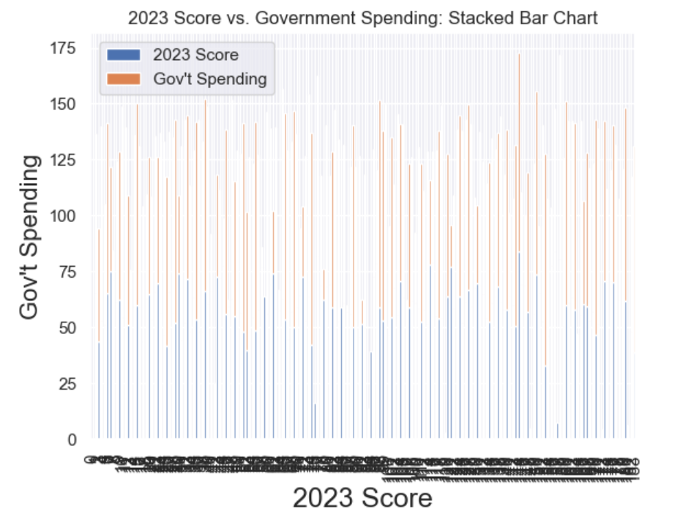

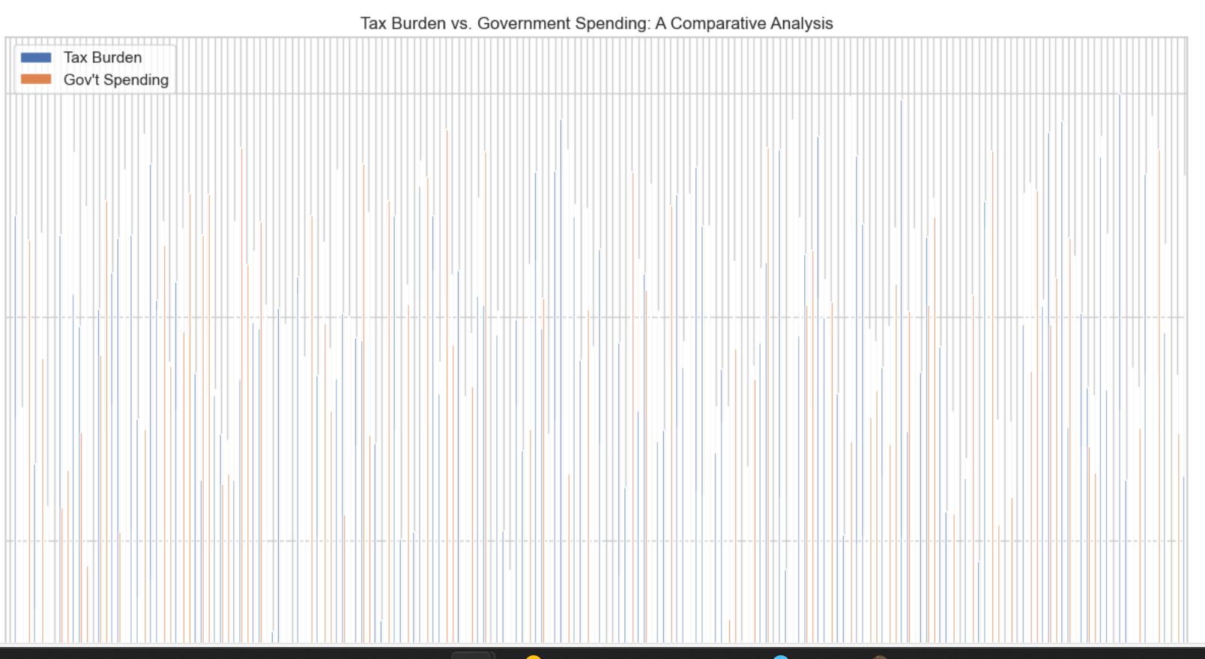

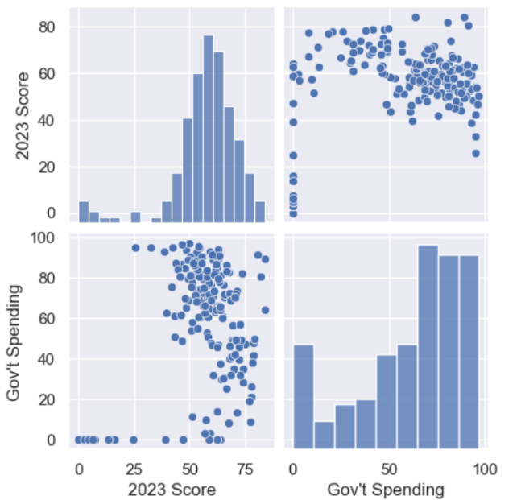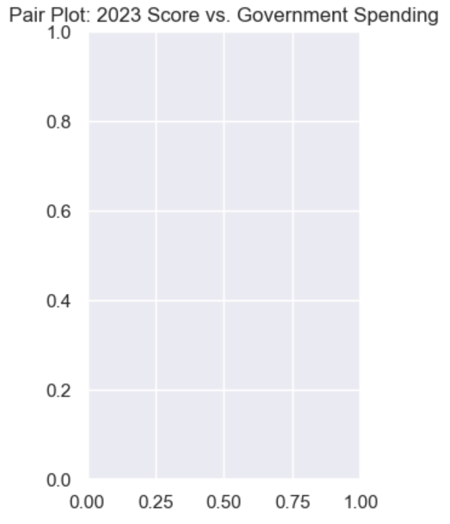

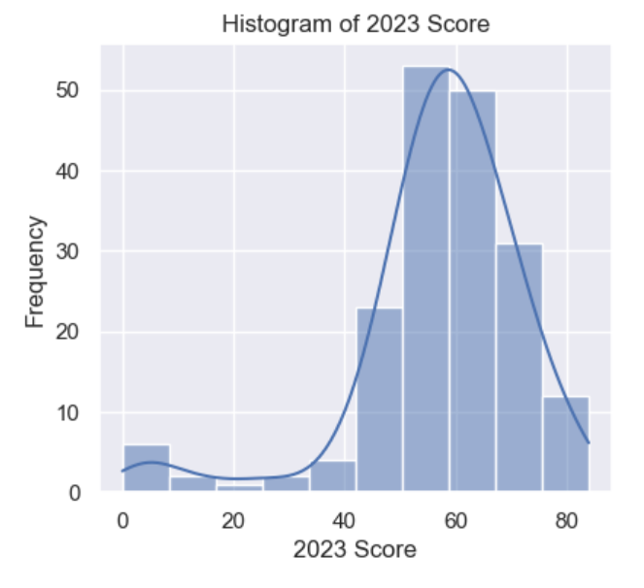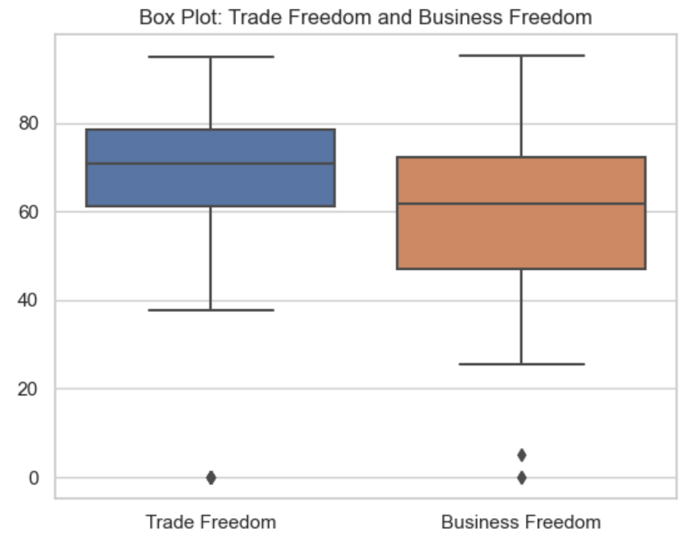

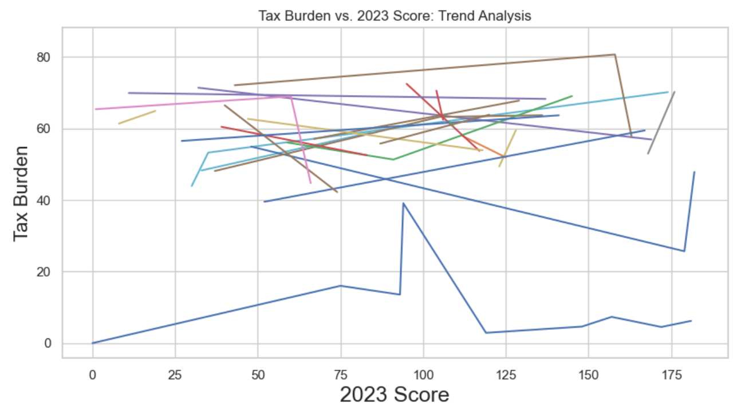

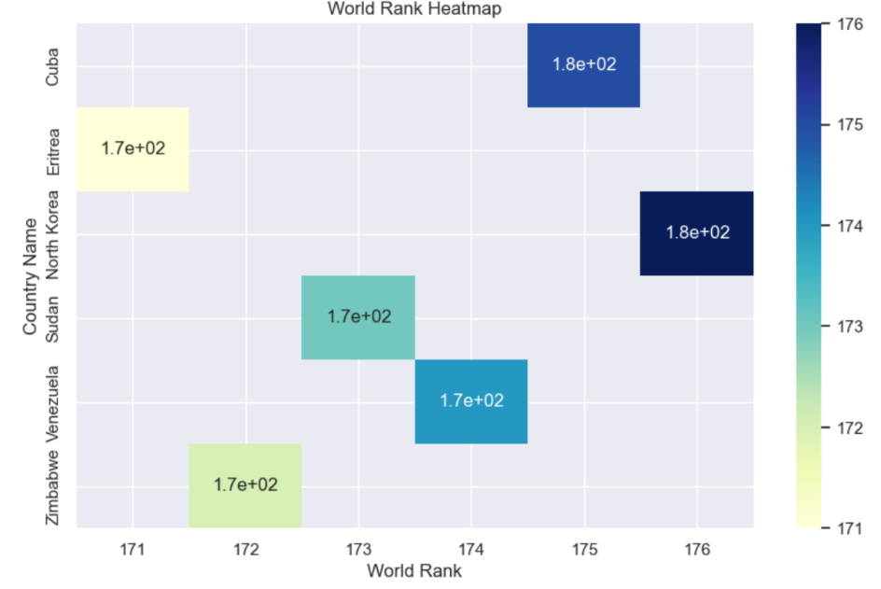

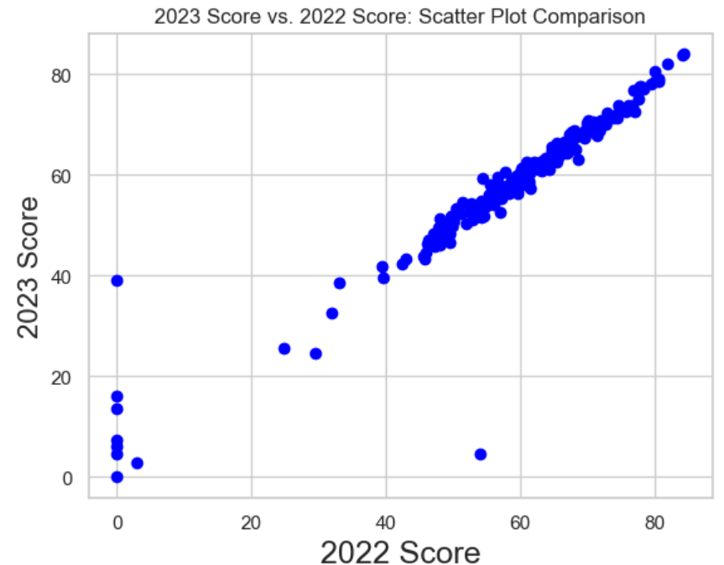

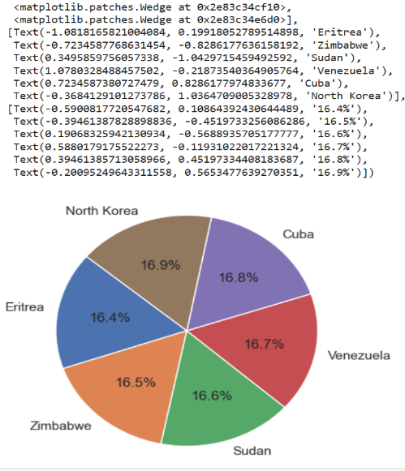

**Conclusion:**

The analysis of the Social Progress Index using Python provides a comprehensive understanding of the social well-being and quality of life in a specific region or country. This index considers a wide range of social and environmental indicators, offering insights beyond traditional economic measures . This analysis provides valuable insights into the economic freedom of countries around the world. It highlights the top and bottom-ranking countries, the distribution of 2023 scores, and the relationships between various economic indicators. Understanding these factors is essential for policymakers and researchers to make informed decisions and policies related to economic freedom.

The findings of this analysis can be used to compare and contrast countries' economic freedom and identify areas for improvement. It can also be a valuable resource for further research and policy analysis